**BIOLOGY**

**Insert School Logo**

**UNIT 3 & 4**

**2019**

**Name**:

**Teacher**:

**Time allowed for this paper**

Reading time before commencing work: ten minutes

Working time: three hours

**Materials required/recommended for this paper**

***To be provided by the supervisor***

This Question/Answer booklet

Multiple-choice answer sheet

***To be provided by the candidate***

Standard items: pens (blue/black preferred), pencils (including coloured), sharpener, correction fluid/tape, eraser, ruler, highlighters

Special items: non-programmable calculators approved for use in this examination

**Important note to candidates**

No other items may be taken into the examination room. It is **your** responsibility to ensure that

you do not have any unauthorised material. If you have any unauthorised material with you, hand

it to the supervisor **before** reading any further.

**Structure of this paper**

|  |  |  |  |  |  |
| --- | --- | --- | --- | --- | --- |
| Section | Number of questions available | Number of questions to be answered | Suggested working time (minutes) | Marks available | Percentage of examination |
| Section One  Multiple-choice | 30 | 30 | 40 | 30 | 30 |
| Section Two  Short answer | 5 | 5 | 90 | 100 | 50 |
| Section Three  Extended answer  Unit 3 | 2 | 1 | 50 | 40 | 20 |
| Unit 4 | 2 | 1 |
|  |  |  |  | **Total** | 100 |

**Instructions to candidates**

1. The rules for the conduct of the Western Australian external examinations are detailed in the *Year 12 Information Handbook 2019*. Sitting this examination implies that you agree to abide by these rules.

2. Write your answers in this Question/Answer booklet preferably using a blue/black pen. Do not use erasable or gel pens.

3. Answer the questions according to the following instructions.

Section One: Answer all questions on the separate Multiple-choice answer sheet provided. For each question, shade the box to indicate your answer. Use only a blue or black pen to shade the boxes. Do not use erasable or gel pens. If you make a mistake, place a cross through that square, then shade your new answer. Do not erase or use correction fluid/tape. Marks will not be deducted for incorrect answers. No marks will be given if more than one answer is completed for any question.

Section Two: Write your answers in this Question/Answer booklet. Wherever possible, confine your answers to the line spaces provided.

Section Three: Consists of two parts each with two questions. You must answer one question from each part. Tick the box next to the question you are answering. Write your answers in this Question/Answer booklet.

4. You must be careful to confine your answers to the specific questions asked and to follow any instructions that are specific to a particular question.

5. Supplementary pages for planning/continuing your answers to questions are provided at the end of this Question/Answer booklet. If you use these pages to continue an answer, indicate at the original answer where the answer is continued, i.e. give the page number.

**Section One: Multiple-choice 30% (30 Marks)**

This section has **30** questions. Answer **all** questions on the separate Multiple-choice answer sheet provided. For each question, shade a box to indicate your answer. Use only a blue or black pen to shade the boxes. If you make a mistake, place a cross through that square, then shade your new answer. Do not erase or use correction fluid/tape. Marks will not be deducted for incorrect answers. No marks will be given if more than one answer is completed for any question.

Suggested working time: 40 minutes.

1. Bacteria can be found in almost every habitat on Earth. This diversity is unexpected due to their mode of reproduction. However, bacteria have evolved a novel way of increasing genetic diversity through the process of conjugation. This involves

(a) swapping DNA with another species of bacteria.

(b) transferring RNA to another bacterial cell.

(c) replication of plasmids that are then transferred into other cells.

(d) transferring DNA into another bacterial cell of the same species.

2. Prokaryotes are different to eukaryotes in that they

(a) contain RNA instead of DNA.

(b) contain no organelles.

(c) do not contain a nucleus.

(d) come in different shapes and sizes.

3. Antibiotics can be used to treat some infections. Which of the following **does not** reflect the action of antibiotics on pathogenic cells?

(a) Unravelling of genetic material.

(b) Destruction of cell membranes.

(c) Disruption of protein synthesis.

(d) Breaking down cell walls.

4. Jaw bones of a small, bird-like dinosaur, *Galleonosaurus dorisae*, have been uncovered in Victoria's Gippsland basin, an area rich in fossil deposits. During the Cretaceous period, this region was connected to Antarctica by a long, rift valley. The jaw bones of *G. dorisae* are believed to be approximately 125 million years old. What method would most likely have been used by palaeontologists to estimate the age of these bones?

(a) Liquid chromatography

(b) Carbon-14 dating

(c) Index fossil comparison

(d) Uranium-238 dating

5. Which of the following most likely represents the environmental conditions in the rift valley 125 million years ago to allow the formation of fossils?

(a) Volcanic activity, weathering and erosion.

(b) Earthquakes, flooding and tidal surges.

(c) Volcanic activity, seafloor spreading and erosion.

(d) High rainfall, volcanic activity and high atmospheric temperatures.

6. Tuberculosis and tetanus are diseases that can be prevented through immunisation and treated with antibiotics. This is because both diseases are caused by

(a) retroviruses.

(b) bacteria.

(c) viruses.

(d) protozoans.

7. Prior to meiosis, a cell has a diploid number of 72. How many chromosomes will be present in each resulting daughter cell?

(a) 72

(b) 144

(c) 18

(d) 36

8. A child is born from parents who are homozygous dominant and heterozygous dominant for a particular trait. What is the chance of the child being homozygous recessive for this trait?

(a) 75%

(b) 0%

(c) 25%

(d) 50%

9. Which of the following statements regarding meiosis is **correct**?

Meiosis;

(a) forms diploid daughter cells.

(b) produces daughter cells genetically identical to the parent cell.

(c) involves independent assortment of alleles.

(d) occurs in every cell of an organism.

10. *Agrobacterium tumefaciens* is a type of bacteria used as a DNA vector in genetic modification techniques. *A. tumefaciens* is utilised over and above other bacterial species because it

(a) utilises the process of transduction, whereby phages carry foreign DNA from bacterium to plant cells.

(b) carries a plasmid that readily receives foreign DNA.

(c) prevents the transmission of disease-carrying agents between plants.

(d) carries antibiotic resistance which is beneficial to plant growth.

Question 11 refers to the image below of a leaf cross section.

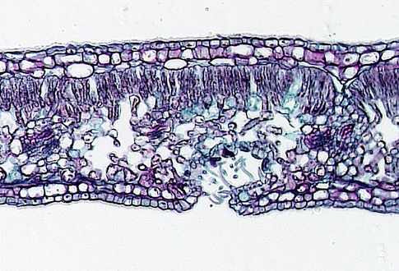

11. The leaf most likely belongs to a

(a) halophyte because it contains vascular tissue.

(b) xerophyte because it has sunken stomata that contain microscopic hairs.

(c) rainforest species because it has no stomata on its upper epidermis.

(d) seagrass species due to the presence of a waxy cuticle.

Question 12 refers to the information regarding nitrogenous waste in the table below.

|  |  |  |  |  |  |
| --- | --- | --- | --- | --- | --- |
| **Animal species** | 1 | 2 | 3 | 4 | 5 |
| **Relative waste toxicity** | High | Medium | High | Low | Low |

12. Based on the toxicity of the waste they produce,

(a) species 1 is a marine fish and species 5 is a lizard.

(b) species 2 is a crocodile and species 4 is an insect.

(c) species 1 is a kangaroo and species 3 is a lizard.

(d) species 2 is a camel and species 3 is a bat.

13. Which of the following statements reflects an accepted theory of how the evolution of eukaryotic cells originated?

(a) Free-floating ribosomes were engulfed by prokaryotic cells to become bacteria.

(b) Large prokaryotes engulfed cyanobacterial cells, which then joined together to form multicellular algae.

(c) Free-living prokaryotic cells were enclosed within large prokaryotes, providing energy in a symbiotic relationship.

(d) Prokaryotic cells absorbed amino acids which were used as building blocks for cellular membranes.

14. Animals living in arid conditions often possess specialised adaptations in order to maintain their internal temperature. Which of the following descriptions reflects the behaviour of an endothermic animal living in the desert?

(a) The marsupial mole spends its entire life tunnelling under the sand.

(b) Kangaroos huddle together under shady trees to conserve energy.

(c) The bilby has large, vascularised ears to allow heat loss.

(d) A tortoise hides in its shell when no shade is available.

15. Samphires are specialised plants, many of which are found growing in and around arid salt lakes. Given this information, a samphire should be classified as

(a) a halophyte.

(b) a xerophyte.

(c) both a halophyte and a xerophyte.

(d) none of the above.

16. Antidiuretic hormone, or ADH, is produced by the hypothalamus. The release of ADH into the bloodstream of mammals is stimulated by

(a) blood filtering through the glomerulus of the nephron.

(b) increasing extracellular osmolarity.

(c) decreasing extracellular osmolarity.

(d) the released of urea from the liver into the bloodstream.

17. The fossils of whale ancestors possess well-developed pelvic and thigh bones. What does this morphology suggest about the ancestors of modern whale species?

(a) They evolved in the marine environment where they remained.

(b) Their ancestors lived in large inland seas that no longer exist.

(c) They became better adapted to living in a terrestrial landscape after life in the ocean.

(d) They became better adapted for the ocean following life on land.

18. A student was completing her PhD on the Southern leaf-tailed gecko (*Saltuarius swaini*), which is found along the north coast of New South Wales. During her field trips to observe the geckos in their natural habitat, she noticed that the length and width of the 'leaf' tail showed significant variation between and within populations. However, the majority of geckos had tails of average size and shape. She came to the conclusion that variation in their tail size was due to

(a) variation in the environment.

(b) polygenic inheritance.

(c) multiple alleles.

(d) co-dominance.

19. Pacific salmon are anadromous, meaning that they are born in freshwater, migrate to the ocean to reproduce and then return to freshwater to spawn. To survive the changes in salt concentration of their external environment, salmon possess specialised adaptations for osmoregulation. When adult salmon migrate back into freshwater rivers, they must

(a) drink copious amounts of water to dilute internal solute concentrations.

(b) actively pump dissolved salts into their body using specialised gill cells.

(c) actively pump salts from their blood into the surrounding water using specialised gill cells.

(d) produce very small quantities of urine to maintain osmotic potential of extracellular fluid.

20. RNA interference (RNAi) is a relatively new form of genetic engineering. It utilises double-stranded sections of RNA to intercept and destroy specific mRNA molecules in the nucleus. In terms of genetic modification, RNAi alters

(a) the genotype and the phenotype.

(b) neither the genotype nor the phenotype.

(c) the genotype but not the phenotype.

(d) the phenotype but not the genotype.

21. If RNA interference results in the destruction of mRNA, then

(a) ribosomes will not be produced.

(b) transcription cannot take place.

(c) the gene will not be translated.

(d) DNA cannot undergo replication.

22. Which of the following questions is of most importance to the conservation of a small population of endangered animals?

(a) How much gene flow is required to prevent inbreeding effects?

(b) Is the population influenced by a keystone species?

(c) Does the species hold economic value to humans?

(d) Will climate change negate the efforts of conservation biologists?

23. A number of enzymes are integral to the process of DNA replication. Which of the following enzymes is not involved in this process?

(a) DNA helicase

(b) DNA replicase

(c) DNA ligase

(d) DNA polymerase

Question 24 refers to the graph below.

Q

24. In the graph shown above, which species is most likely a marine fish?

(a) Q

(b) R

(c) S

(d) T

25. Ozaki fragments are added

(a) in a 3' to 5' direction.

(b) in a 5' to 3' direction.

(c) in the same direction as the leading strand.

(d) in the order in which they arrive at the DNA template strand.

26. The evolution of a new species through geographical isolation is a function of

(a) sympatric speciation.

(b) allopatric speciation.

(c) genetic drift.

(d) mutation.

27. A long loop of Henle allows greater water reabsorption in some desert-living marsupials. This adaptation is

(a) physiological.

(b) structural.

(c) both structural and physiological.

(d) behavioural.

28. Which of the following best represents the role of humans in artificial selection?

(a) Perform artificial insemination.

(b) Produce transgenic organisms which are then bred.

(c) Choose the organisms that will become breeding stock.

(d) Select which organisms should live and which should die.

29. A student wanted to investigate different types of unknown plants to determine which were xerophytes. The most effective quantitative method to achieve his aim would be to

(a) count the number of open stomata during the middle of the day.

(b) determine the dry weight mass of salt crystals deposited on the leaves of the plants over a 24-hour period.

(c) compare their transpiration rates at different times of the day.

(d) measure the amount of oxygen produced by each plant over an hour.

30. Varroa mites (*Varroa destructor*) have become the most damaging pest to western honey bee (*Apis mellifera*) colonies and the primary cause of their decline. Female Varroa mites feed on the haemolymph of developing and adult bees and can transmit viruses from one bee to another. Given this behaviour, it could be said that the Varroa mite is a

(a) parasite.

(b) disease vector.

(c) vectored pathogen.

(d) parasitic vector.

**End of Section One**

**Section Two: Short answer 50% (100 Marks)**

This section has **five (5)** questions. Answer **all** questions. Write your answers in the spaces provided in this Question/Answer booklet. Wherever possible, confine your answers to the line spaces provided. Use a blue or black pen for this section. Only graphs and diagrams may be drawn in pencil.

Additional working space pages at the end of this Question/Answer booklet are for planning or continuing an answer. If you use these pages, indicate at the original answer the page number it is planned/continued on and write the question number being planned/continued on the additional working space page.

Suggested working time: 90 minutes.

**Question 31 (20 marks)**

A market gardener planted 400 blueberry plants derived from a single mature bush. These new plants were established using plant tissue culture techniques. Before they were planted in the ground, the blueberry plants were kept in a greenhouse and exposed to the same environmental conditions. The blueberries were planted in the ground using the same fertiliser, soil conditioner, compost and sowing techniques. The plants are water daily for one hour via a drip irrigation system and receive the same amount of sunlight.

After five months, the market gardener was quite surprised to find that the plants were growing at different rates and were of different shapes and sizes. Given that the 400 blueberry plants were grown from tissue derived from one single plant, he assumed they would be identical.

(a) Discuss the mechanisms influencing phenotypic expression of the blueberry plants. (4 marks)

After the first fruiting season, the market gardener collected and processed blueberry seeds from each plant. He was hoping to increase the genetic variation of his crop by germinating and planting the seeds he collected.

(b) Explain whether the plants that germinate from the seeds he collected will be genetically different to the original 'parent' blueberry bush. (4 marks)

(c) Suggest an alternate method the market gardener could employ, using only the plants he has, to increase the genetic diversity of his crop in the future. (2 marks)

(d) Propose **two (2)** problems that could arise from growing genetically identical plants.

(4 marks)

(e) Suggest how the phrase "Survival of the Fittest", as coined by Charles Darwin, relates to the market gardener's situation. (2 marks)

Polyploidy is a common phenomenon in plants and often utilised by flower and fruit growers due to some of the advantageous effects.

(f) Explain how polyploidy occurs in plants and identify a resulting trait that would be beneficial to fruit growers. (4 marks)

**Question 32 (20 marks)**

Dieback is caused by infection with the pathogenic 'water mold' *Phytophthora cinnamomi*. Dieback has become widespread throughout Western Australia, with particular effect on species within the Jarrah forest and Banksia woodlands.

(a) Define the term 'pathogen'. (2 marks)

(b) Describe the effect of a *P. cinnamomi* infection on a susceptible species such as the Jarrah tree (*Eucalyptus marginata*). (3 marks)

(c) Explain why *P. cinnamomi* is also referred to as a parasite. (2 marks)

Consider the image below.

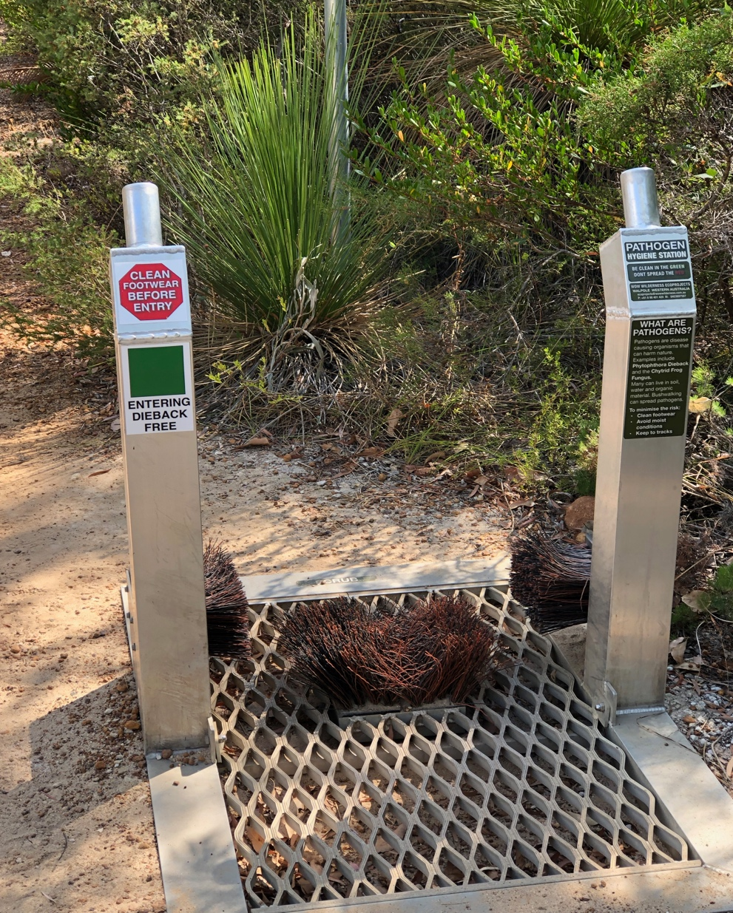

(d) Explain the importance of establishing 'boot cleaning' stations, such as the one pictured above, along public walking trails through native bushland. (4 marks)

(e) Identify **three (3)** quarantine procedures used in Australia to prevent the spread of plant pathogens or disease. (3 marks)

Microorganisms are recognised for their ability to reproduce rapidly, thereby increasing the potential to infect and spread throughout a host population. Rapid reproduction also supports rapid evolution which, in the case of bacteria and viruses, can lead to resistance to common pharmaceutical treatments.

(f) Explain how bacteria can evolve to express antibiotic resistance, through natural selection. (6 marks)

**Question 33 (20 marks)**

(a) Define 'homeostasis'. (2 marks)

(b) Identify the body systems involved in homeostatic processes. (2 marks)

In the film 'The Hunger Games - Mockingjay Part 1', President Coin requests a reduction in the oxygen levels to 14% during a bombing attack on District 13.

(c) Describe the physiological response of an individual confined to an area with a reduced oxygen content. Use the stimulus-response model to support your answer.

(6 marks)

(d) Explain why most stimulus-response models involve negative feedback. (4 marks)

Different organisms control their internal body temperature in different ways.

(e) Explain the difference between an ectotherm and an endotherm in terms of internal temperature control. (2 marks)

(f) Describe **two (2)** behavioural responses of an ectotherm, such as a lizard, trapped in the hot sun for an extended period of time. (4 marks)

**Question 34 (20 marks)**

Due to the provision of nationwide immunisation programs many incurable diseases (poliomyelitis, Diphtheria and smallpox), that have been around for hundreds of years, have been eradicated from the Australian population. However, there is an increasing trend in the wider Australian community to not vaccinate children against these preventable diseases. Some anti-immunisation supporters believe that "vaccines can cause autism and Down syndrome" and that "the diseases are old-fashioned and don't exist anymore".

(a) Formulate a response to both anti-immunisation claims. In your responses, explain why each statement is both incorrect and harmful to the community.

(i) "Vaccines can cause autism and Down syndrome". (4 marks)

(ii) "They are old-fashioned diseases that don't exist anymore". (4 marks)

Influenza, or the 'flu', is a common illness that is most prevalent during the winter months. There are three main types of influenza - A, B and C, with type A being the most virulent.

(b) Explain the term 'virulent'. (2 marks)

Type A Influenza includes a number of strains such as swine flu (H1N1) and avian flu. These strains of influenza A can be transmitted between humans and animals.

(c) Identify the term used to describe a disease that can be transmitted between different species and explain why these particular diseases can be problematic to human populations. (4 marks)

(d) A new vaccine for Influenza A is developed every year. Explain why this is necessary.

(3 marks)

(e) Explain why diseases such as influenza and measles cannot be treated with antibiotics.

(3 marks)

**Question 35 (20 marks)**

Recent studies in China have discovered alarming levels of bacteria in the thick smog that often blankets many cities. Vehicle exhaust and burning of coal for power are the main contributors of the toxic smog. The airborne bacteria have been traced back to wastewater treatment plants, where they use bacteria to break down organic matter, and from pharmaceutical companies that use genetically engineered bacteria in the production of medicines.

A group of PhD students investigated the effect of smog levels on the airborne bacterial load in Beijing. The data presented below are their results that were collected from various different sites a number of times during the year.

**Table 1** - Mean smog and bacteria levels throughout Beijing.

|  |  |
| --- | --- |
| **Mean smog levels (μg/m3)** | **Mean bacterial load x 103 (m3)** |
| 91.3 | 65 |
| 82.9 | 58 |
| 64.3 | 42 |
| 21.4 | 6 |
| 38.1 | 10 |
| 52.7 | 25 |
| 68.9 | 40 |
| 49.4 | 21 |
| 42.3 | 18 |
| 50.6 | 27 |
| 72.8 | 49 |
| 88.7 | 61 |

(a) Identify the independent and dependent variable in this investigation. (2 marks)

Independent

Dependent

(b) Propose an appropriate hypothesis for this investigation, based on the variables identified in part (a). (2 marks)

(c) Construct an appropriate graph of the data, represented by the independent and dependent variables, in the space provided below. (6 marks)



(d) Explain any patterns in the data presented in the graph. (2 marks)

(e) Identify **two (2)** variables that need to be controlled in this investigation. Explain why controlling these variables is important for data validity. (4 marks)

(f) Suggest **two (2)** ways in which the scientists could improve or expand their investigation to provide more comprehensive data. (2 marks)

(g) Explain why the release of genetically modified (GM) bacteria into the atmosphere could pose a problem for the wider community. (2 marks)

**End of Section Two**

**Section Three: Extended answer 20% (40 marks)**

This section contains **four (4)** questions. You must answer **two (2)** questions; **one (1)** from Unit 3 and **one (1)** from Unit 4.

Use black or blue pen for this section. Only graphs and diagrams may be drawn in pencil. Responses can include: labelled diagrams with explanatory notes; lists of points with linking sentences; labelled tables and/or graphs; and/or annotated flow diagrams with introductory notes.

Additional working space pages at the end of this Question/Answer booklet are for planning or continuing an answer. If you use these pages, indicate at the original answer, the page number it is planned/continued on and write the question number being planned/continued on the additional working space page.

Suggested working time: 50 minutes

**Unit 3**

Choose **either** Question 36 **or** Question 37.

Indicate the question you will answer by ticking the box next to the question. Write your answer on pages 25 - 27. When you have answered your first question, turn to page 28 and indicate the second question you will answer on that page.

**Question 36 (20 marks)**

Sickle-cell anaemia is an inherited disease caused by point mutations, resulting in cresent-shaped red blood cells and free-floating haem molecules in the blood plasma.

(a) Explain how a point mutation within a gene can result in the development of a genetic disease like sickle-cell anaemia. (10 marks)

The world's smallest reptile, a dwarf leaf chameleon (*Brookesia micra*), is endemic to a small islet on the northern tip of Madagascar. This species was only discovered in 2012, likely due to its diminutive stature - the male measures 16 millimetres and the female up to 30 millimetres. Mitochondrial DNA comparisons show that *B. micra* diverged as a single species around 20 million years ago. The tiny chameleon survives within the leaf litter of the islet's forest, feeding on small invertebrates.

(b) Discuss the mechanisms involved in the evolution of the dwarf leaf chameleon, *Brookesia micra*. (10 marks)

OR

**Question 37 (20 marks)**

(a) Discuss the function of restriction enzymes and their importance to the development of genetic engineering techniques. (10 marks)

(b) Discuss why homologous structures support the concept of adaptive radiation. Use specific examples to support your response. (10 marks)

**Question**

**Unit 4**

Choose **either** Question 38 **or** Question 39.

Indicate the question you will answer by ticking the box next to the question. Write your answer on the pages provided.

**Question 38 (20 marks)**

Living in a freshwater environment has enabled the evolution of specialised homeostatic mechanisms to regulate osmotic potential and excretion of wastes.

(a) Discuss the mechanisms by which freshwater fish maintain their internal solute and water balance. (10 marks)

(b) Compare the transmission of pathogens through direct and indirect contact and identify the types of infection associated with each. (10 marks)

OR

**Question 39 (20 marks)**

(a) Describe the structural, functional and behavioural adaptations of endotherms that inhabit cold environments. Use specific examples to support your answer. (10 marks)

(b) Compare the disease-causing agents that cause malaria and Ross River virus. Suggest how climate change could affect the transmission and distribution of these diseases in the future. (10 marks)

**End of Exam**

**Question**

**Acknowledgements**

**Question 4**

https://www.abc.net.au/news/2019-02-11/search-for-prehistoric-mammal-flat-rocks-inverloch/10798700

https://www.smithsonianmag.com/smart-news/new-dinosaur-species-found-australia-reveals-lost-world-180971681/

**Question 11 -** Leaf cross-section

Berkshire Community College Bioscience Image Library, Creative Commons.

**Question 24** - Graph "*Changes in core body temperature of four different species over a 24-hour period"*

Author constructed.

**Question 32** - Image of boot washing station, Dunsborough.

Author's own.

**Question 35**

Zhang, T., Li, X., Wang, M., Chen, H. & Yao M. (2019) *Time- and size-resolved bacterial aerosol dynamics in highly polluted air: new clues for haze formation mechanism.* bioRxiv.

http://dx.doi.org/10.1101/513093.